CITI Training Guide
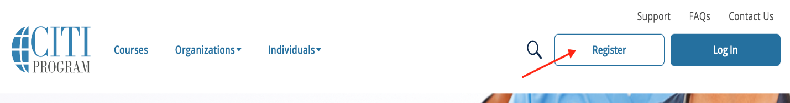
Registering for CITI Training

- To register a new account, visit our homepage, https://www.citiprogram.org/, then click on the Register button.​

- There are two options when creating a CITI Program account: Selecting your Organization Affiliation or Independent Learner Registration. Select Selecting your Organization Affiliation to continue with registration.
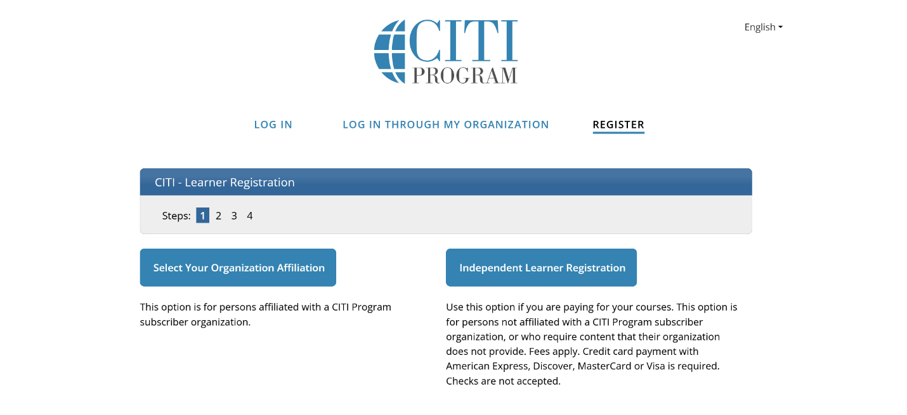

- Enter Womans (no apostrophe) as your institution and click the box next to “I Agree” to the Terms of Service. Click the Create a CITI Program Account button to continue.
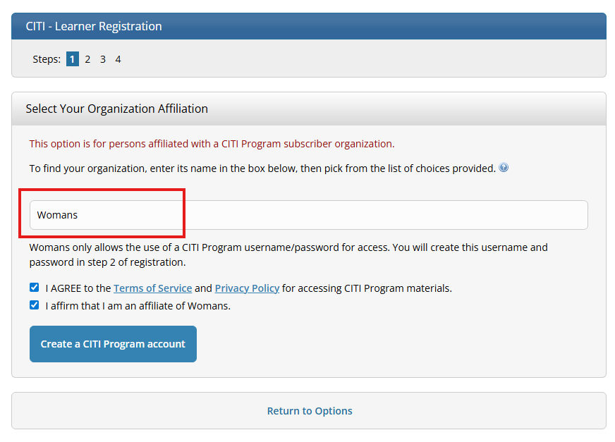

- Complete the registration steps
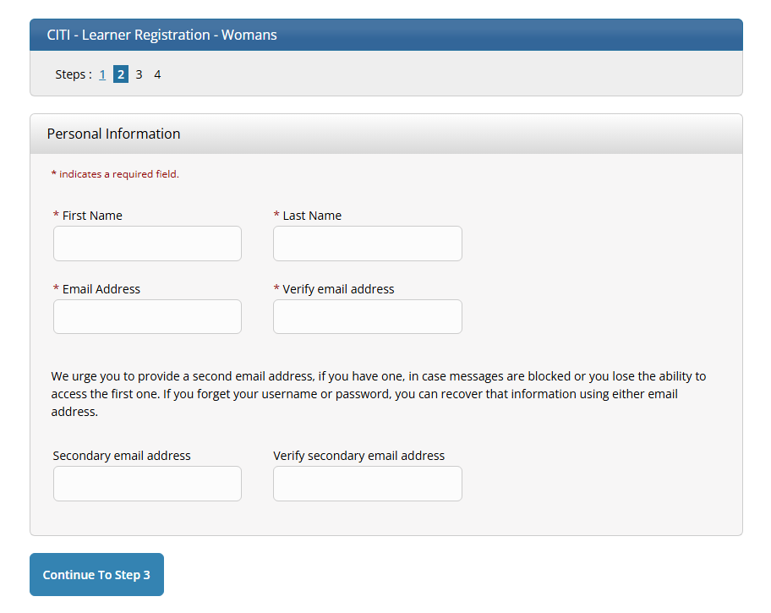
  - Creating log in credentials

  - Step 3: Adding a Security Question and Answer
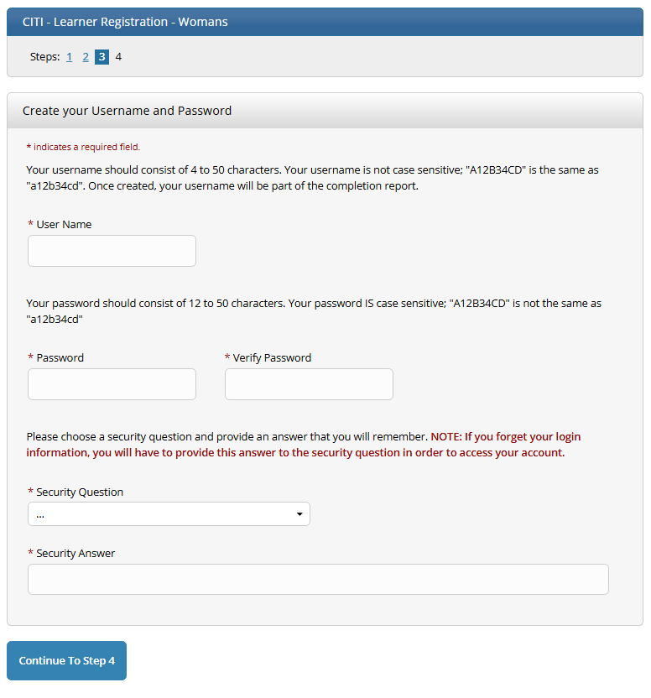

  - Step 4: Adding Country of Residence [Optional: Connecting your ORCID iD]
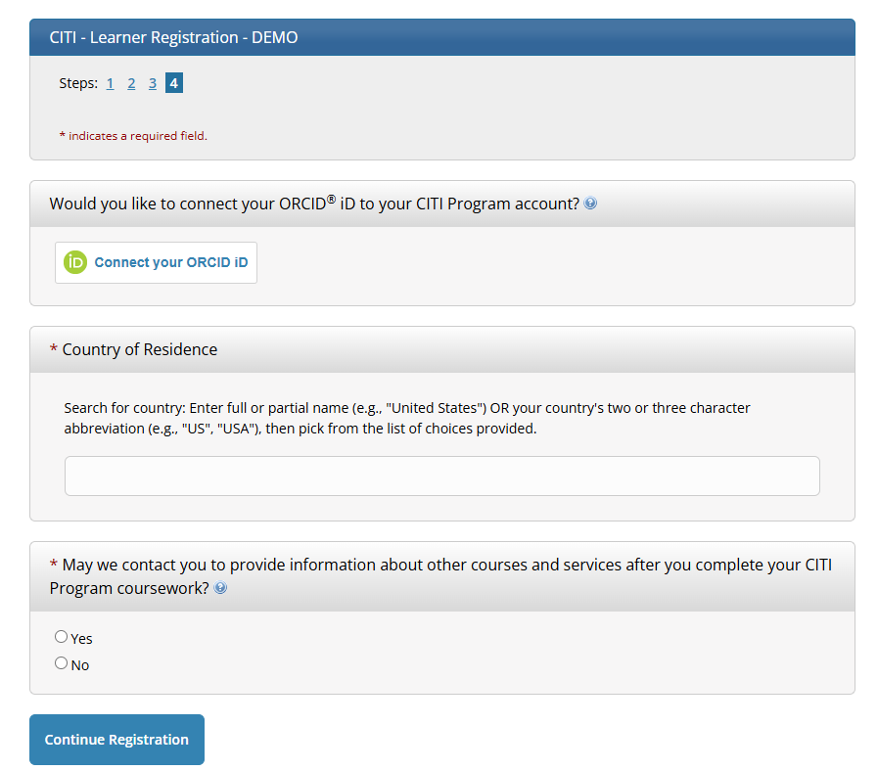
- After clicking the Continue Registration button you will be redirected to:
- Select Continuing Education Credit preferences
- Select your courses from the available curricula offered through your organization. You will be presented with a series of questions or options to enable you to enroll in the courses appropriate to the curriculum selected by your institution.
- Logging In
Go to https://www.citiprogram.org/login ​or click the login button from the homepage.
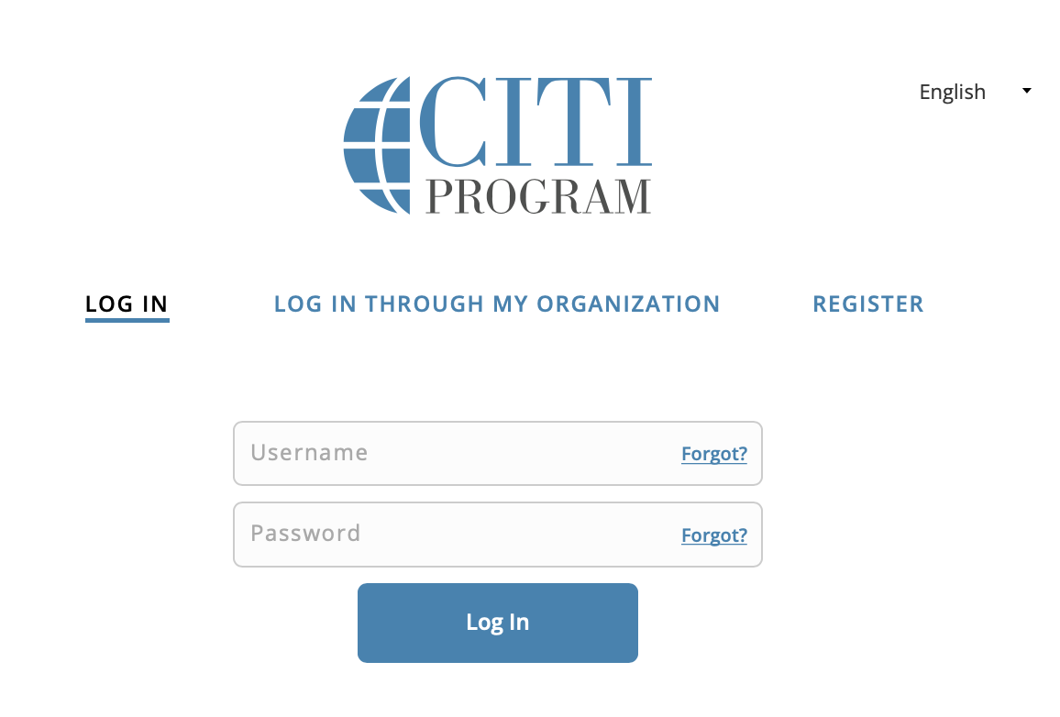
Logging in with CITI Program Credentials
Enter your username and password created during registration and click the Log In button.
If you have forgotten your CITI Program username or password , click the Forgot links to retrieve your username or reset your password.
7. Your Institutional Affiliations
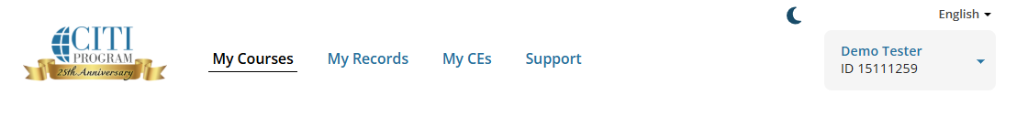
After logging in, your starting point is the My Courses page.
Your courses are listed by institution.
You may affiliate with more than one institution. If there are modules duplicated between the course requirements of multiple institutions, you will only be required to take those once, and credit will be transferred.
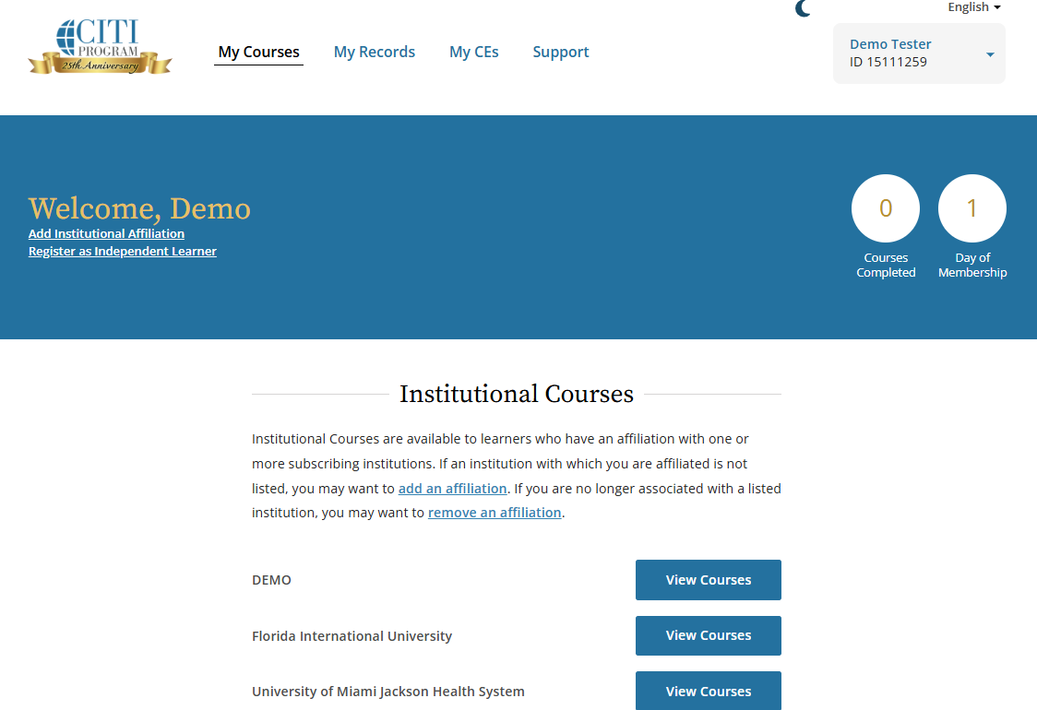
If an institution which you are affiliated with does not appear on the list, click on Add an Affiliation.
8. Your Assigned Courses
Click the View Courses button next to the affiliation to begin courses.
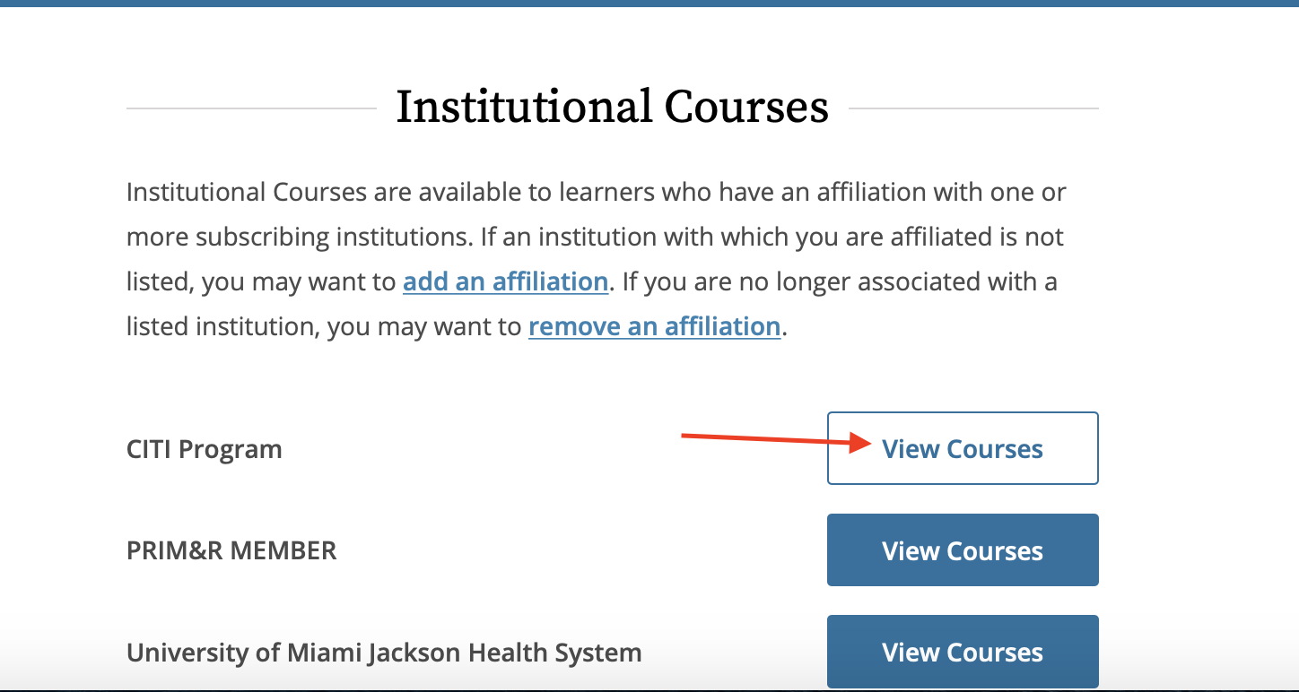
After you click on the View Courses button for an affiliated institution, you will see a course listing for that institution.
The course listing is divided into:
- Active Courses (courses you have started)
- Courses Ready to Begin (not yet started)
- and Completed Courses
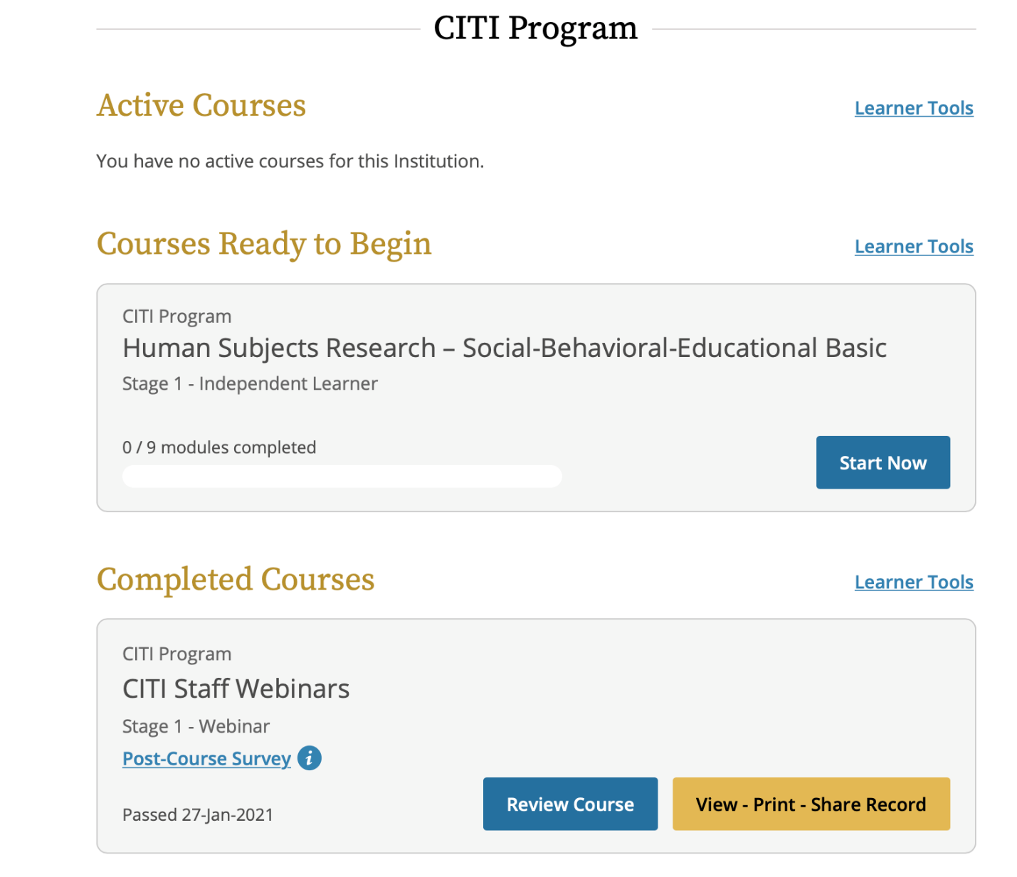
Learner Tools are available for each organizational affiliation.
The Learner Tools provide options designed to help you​ with tasks for that institution's courses:
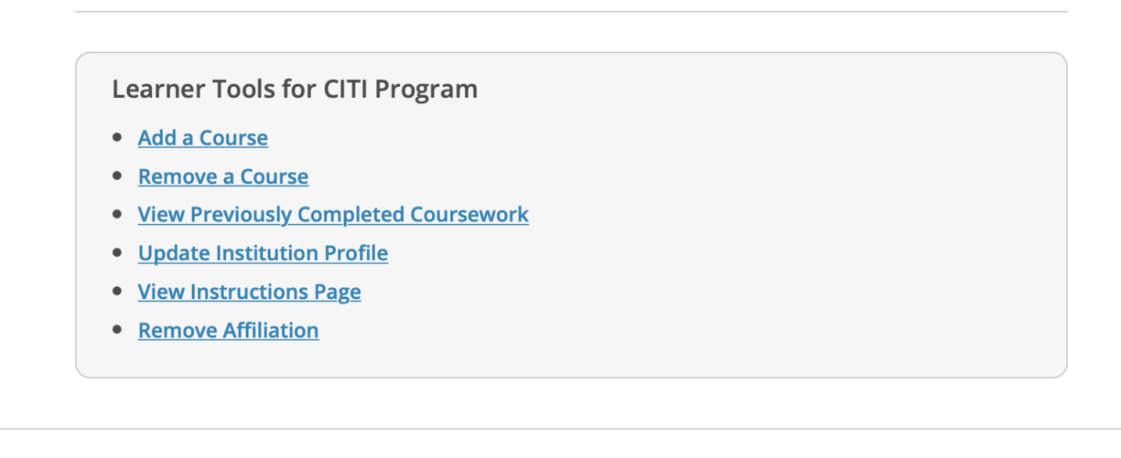
- Add a Course takes you to the institution's course enrollment questions where your responses will place in a course.You will be presented with a series of questions or options to enable you to enroll in the courses appropriate to the curriculum selected by your institution.
- Remove a Course takes you to your current course list, allowing you to remove any courses that are not not needed.
- View Previously Completed Coursework allows you to see your past scores, view course expiration dates, and print-view-share completion records.
- Update Institution Profile allows you to update your institution specific details, such as your institutional ID or employee number, email, department, role in research, etc.
- View Instructions Page provides institution specific information, if your institution has provided it.
- Remove Affiliation allows you to remove the institutional affiliation.

9. Starting and Completing Your Courses
Click the Start Now button to begin the course.
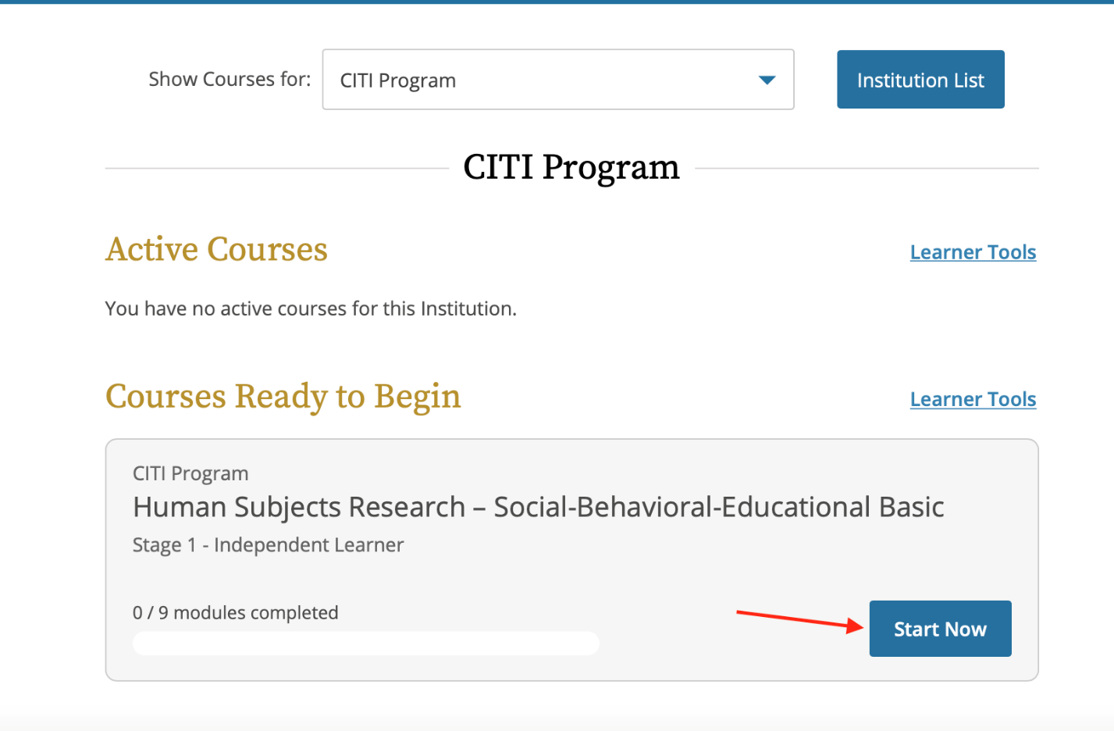
The first time you access a course you must complete the Integrity Assurance Statement. The system will not allow you to start the course modules until you have clicked the "accept" boxes.
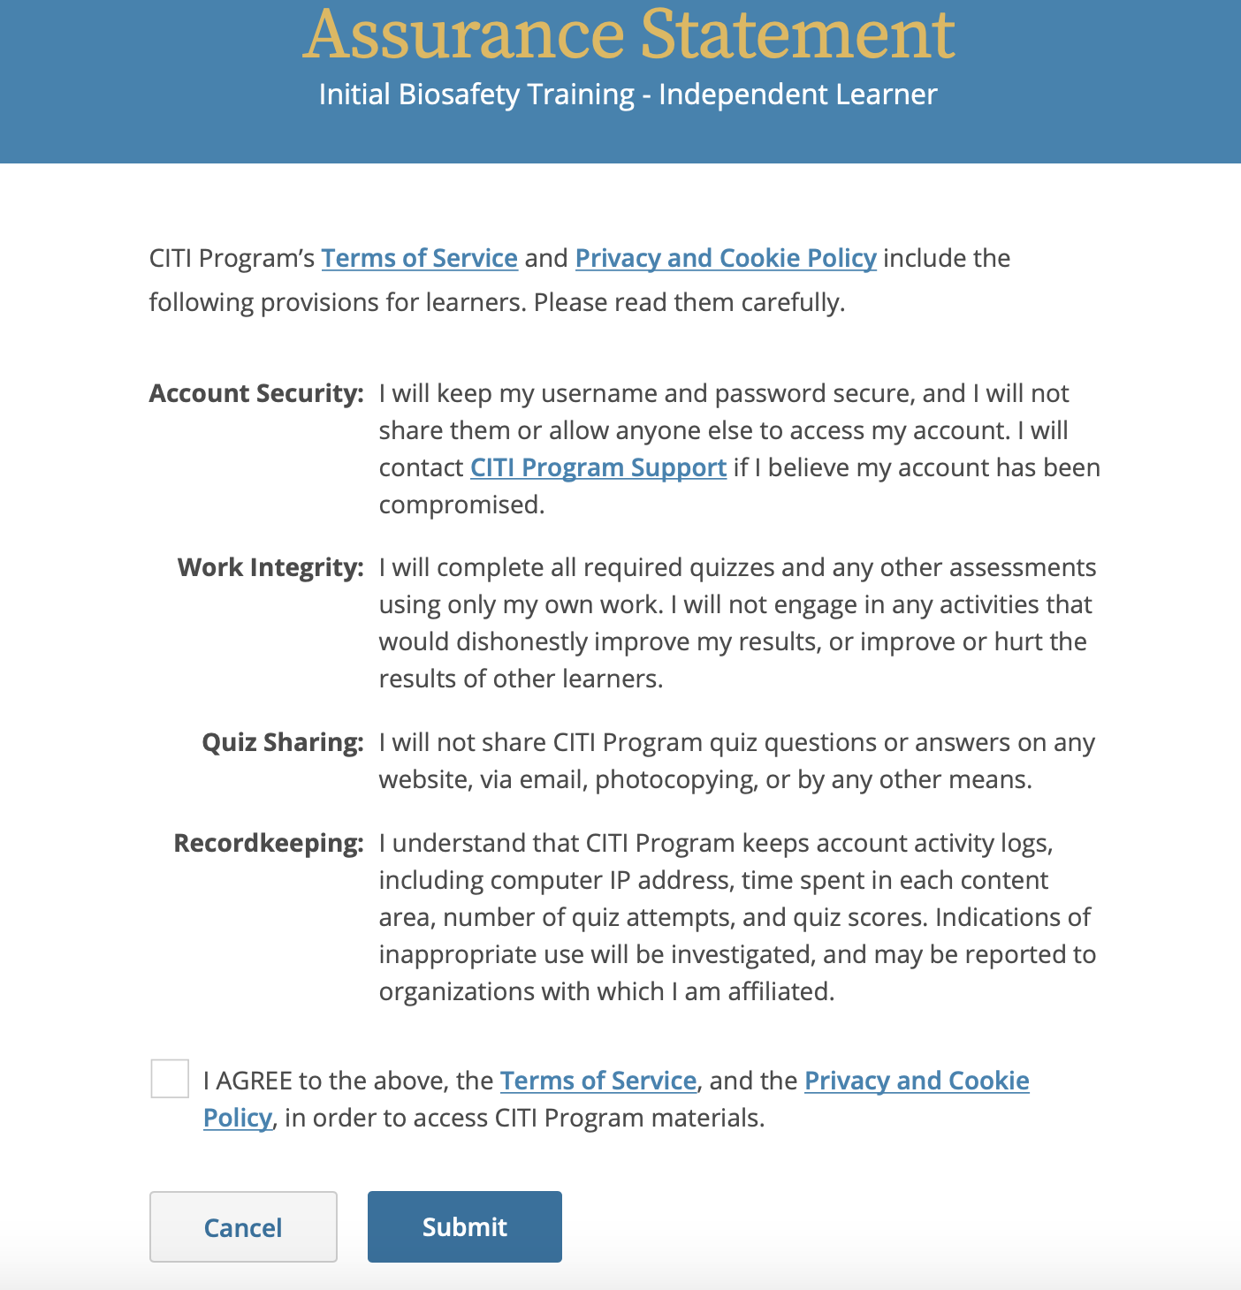
On the Course/Gradebook page you will find:
- Instructions - the number of modules you must complete, and the average passing score required to pass the course. These requirements are specific to this institutional course.
- Progress - the number of modules you have completed in the course out of the total number of modules required.
- Score - your current average score. Quiz Scores are calculated by dividing the number of correct answers by the number of the total answers, multiplied by 100.
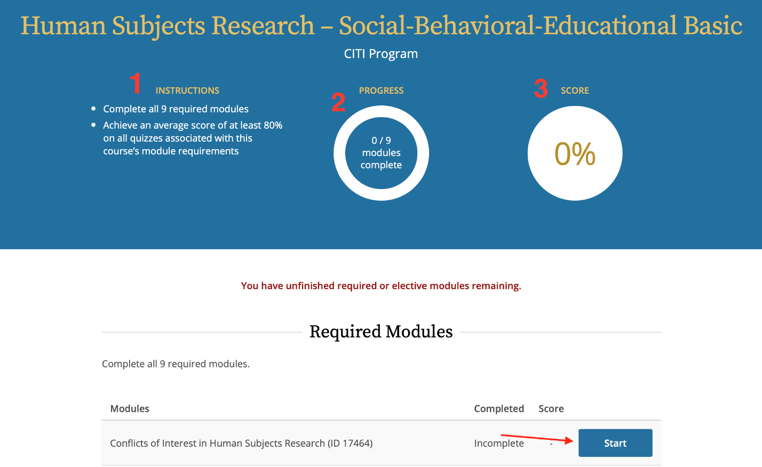
Click the Start button for the first incomplete required module to begin the course.
Some modules offer multiple formats of display.
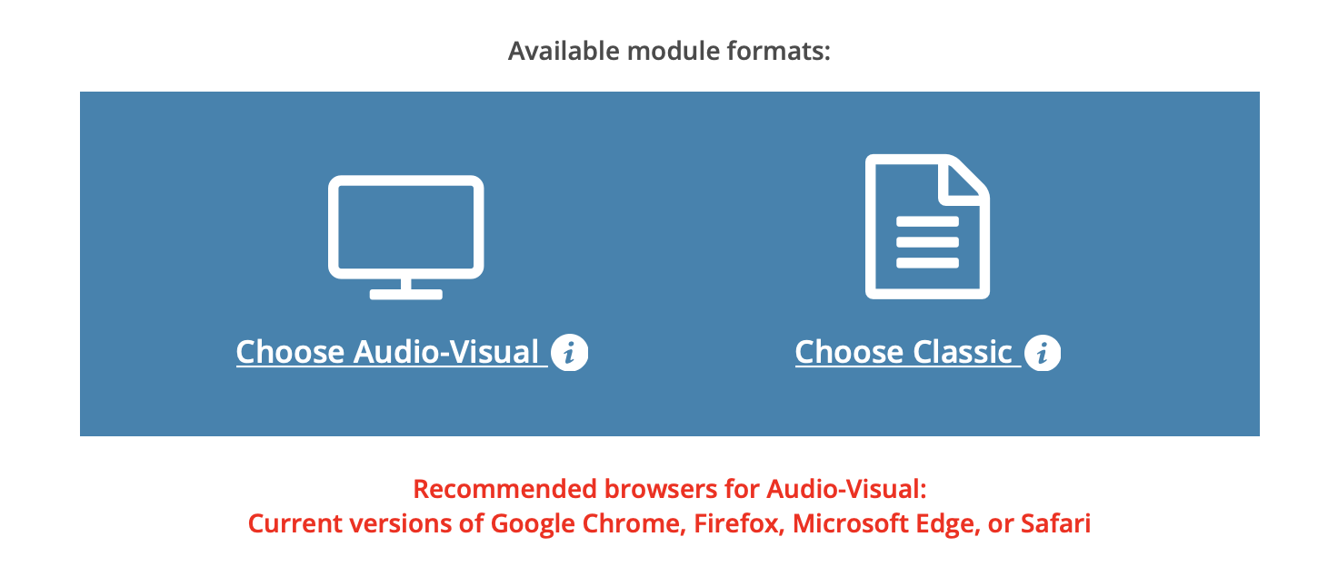
- Audio Visual - For learners who prefer a more dynamic visual presentation, with optional audio narration. Suitable for the larger screens of desktops and laptops.
- Classic - For learners who prefer a more static text and image format. Suitable for any screen size, screen readers, and slower connections.
After reviewing the module content take the quiz to move to the next required module.
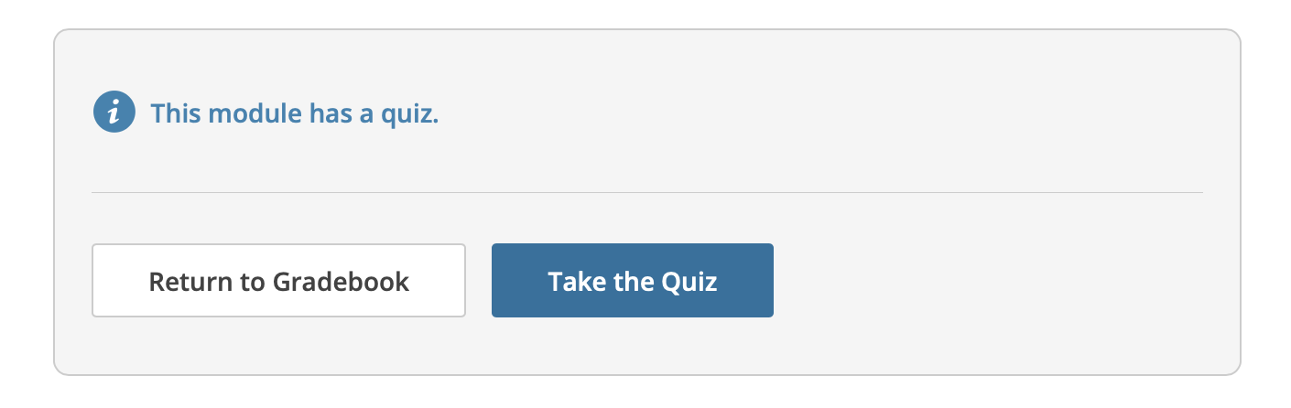

10. Sharing Your Course Completions
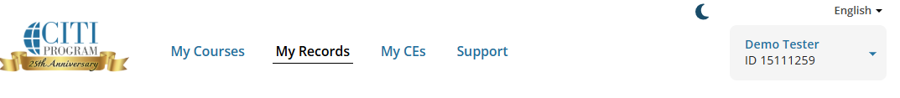
You can also access your completion records through the My Records tab which provides the completion records for all course completions on your account.
Each records includes;
- Stage - if applicable this list the stage of course such as basic or refresher
- Record ID - a unique number assigned to this completion
- Passing Score - the score required by the institution to pass
- Your Score - the score you achieved to meet passing requirements
- Start Date - the date you started the course
- Completion Date - the date you completed the course
- Expiration Date - if applicable, the date the institution has set for this course to expire
- Gradebook - a link to review the modules in the gradebook or take additional optional modules
- Completion Record - provides access to your completion documents
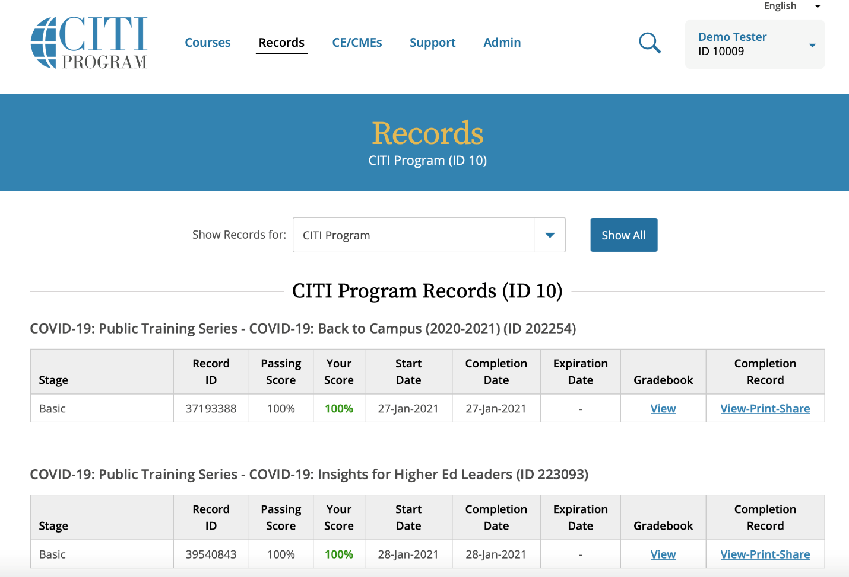
To access the completion documents, click on View-Print-Share under Completion Record.
CITI Program offers two different documents to reflect a course completion:
- Completion Reports are transcripts that include all quiz scores. Part 1 shows scores at the time you completed and passed the course. Part 2 reflects any subsequent quiz attempts.
- Completion Certificates are diplomas that do not include quiz scores. They are more suitable for sharing on sites like LinkedIn.
Each Completion Report and Completion Certificate has a unique "verify" link that you can send to others to share your results (or use for online posting).
