IRB MANAGER USER INSTRUCTIONS

IRB Manager is a web-based system designed specifically for the IRB review process.
To log in to IRB Manager, go to womans.my.irbmanager.com
If you need a login ID and password, please contact the Woman’s Hospital Research Center at 225-231-5275 or research@womans.org
This manual includes:
- The IRB Manager dashboard
- How to submit an initial study for IRB review
- How to submit study-specific submissions, like continuing review and revisions
- Viewing specific study submissions
- Contact information for questions
Click any link above to jump to a specific topic.

DASHBOARD
When you log in to IRB Manager, the page you see is called your “dashboard”.
On your dashboard, you can view all the studies that you are associated with, submit new studies or forms to the IRB, and track the progress of your submissions.
On the left menu, you will see actions you can take regarding your studies, any recent items you have had open, current messages from the research department, and useful links to help you with your submissions.

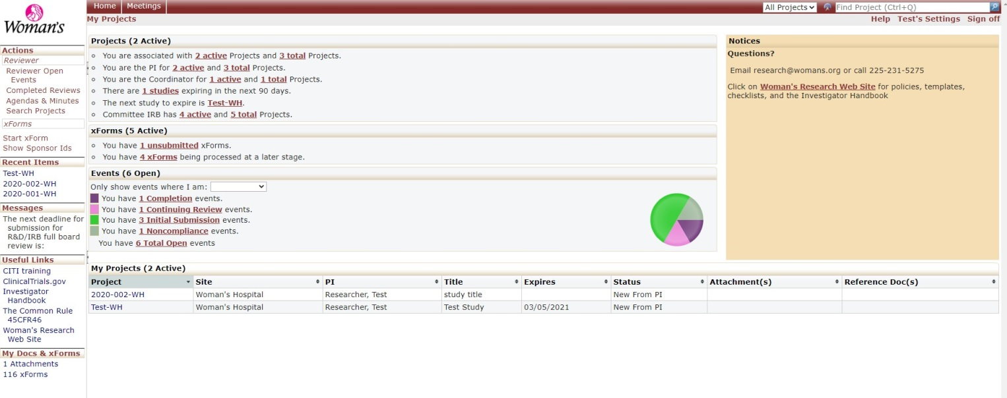
Your profile information is on the top menu bar. Here you can update your password, profile, and contact information, and also add any attachments you may need to use for your studies, like a CITI training certificate or a CV. You can use this feature to upload any general attachments that are not associated with any particular study.
To get back to your dashboard at any time, just click on “home.”
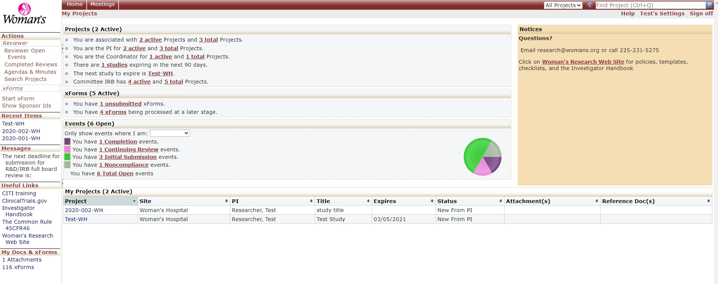
Return to top

In the center of the dashboard, you will see a summary of any projects you are associated with, the status of any of your submitted xForms, events of studies you are associated with, and a list of your studies.
On the right side of the menu, you can click a link to access the research Web site. There is contact information listed here for the research department, or you can also go to the top of the screen under “Help” to contact the administrator.

How to Submit a New Study for Review
Submission forms in IRB Manager are called xForms. You will submit an xForm for an initial submission, continuing review, study revisions, or any other submission you may need to make to the IRB. Submissions, like initial or continuing review, are called events.
To start a new study submission, click on “start xForm” on the left menu. Choose “Initial Submission” to start the xForm. You will be able to upload all of your study information here. Go through the form and answer the questions, and include any attachments. On some questions you may see a “show help” option to assist you with answering the question.

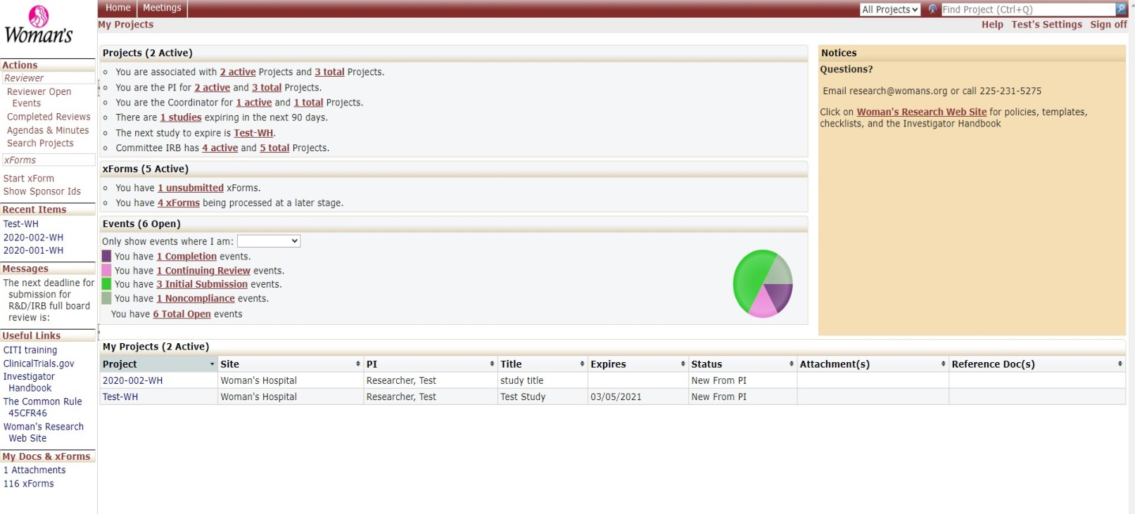
Return to top

Once you have completed the initial submission xForm, the submission will be sent to the Principal Investigator for sign-off (if the submitter of the form is someone other than the PI). From there, it will be routed the WHRC for pre-review, then on to the appropriate reviewer electronically. You can always log in to IRB Manager to check on the status of your submission and see where it is in the review process. You will also receive notifications about your study if there is anything you need to do, such as submit revisions.
For Submissions of Current Studies (Continuing Review, Revisions, Etc.)
If you need to submit an xForm for a current study, like a revision or an adverse event report, or see the details and progress of a study, go to the actual project page by either choosing the project listed under “My Projects”, or in your Recent Items list, or by searching for the project in the “Find Project” search bar at the top of the dashboard.
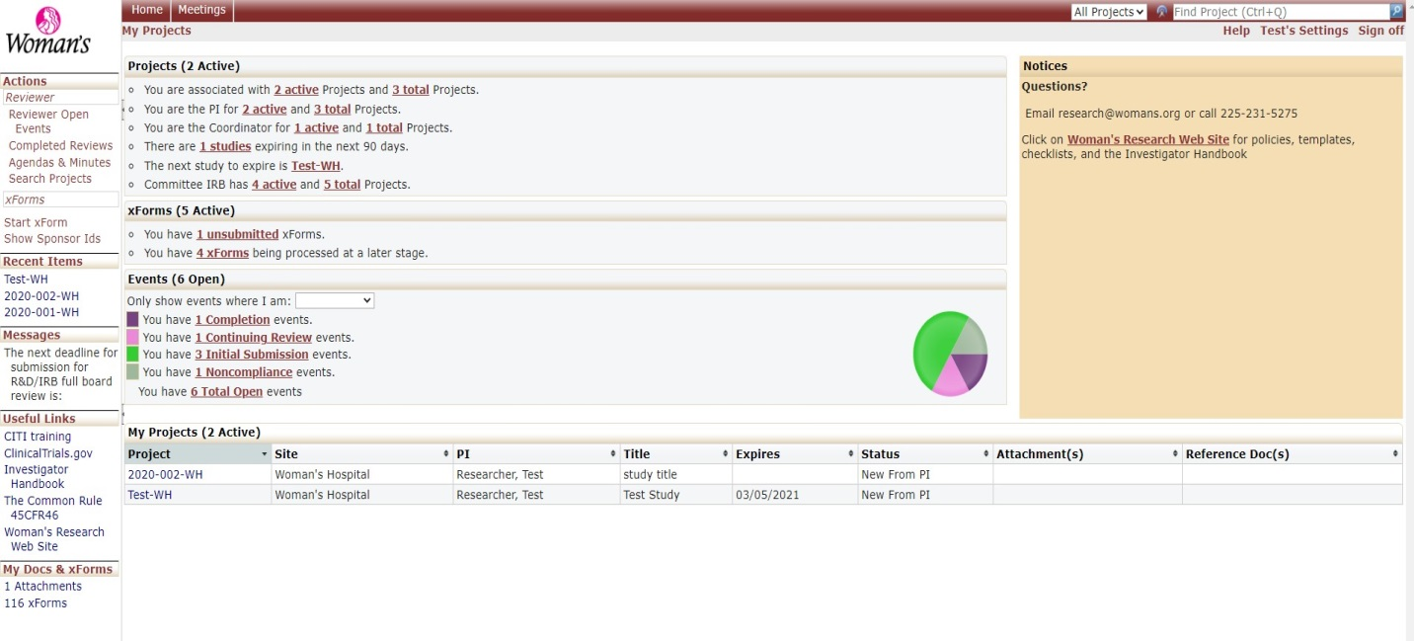

On this study-specific page, you’ll see the study details, project contacts, any reviews on any open submissions, and any submission events. Any email correspondence you have received from IRB Manager regarding the study will also be accessible here.
Return to top

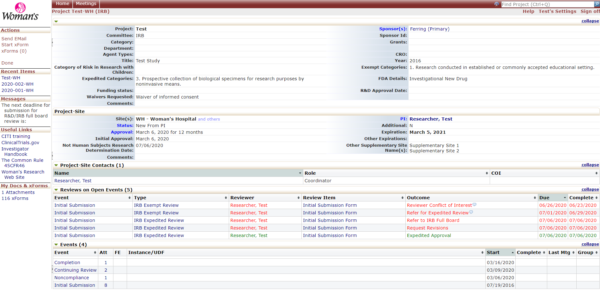
On this study page, you can choose “start xForm” to submit a Continuing Review, a revision to the study, or any other kind of submission specific to the study.
Viewing Specific Study Events
On the study page, if you choose a specific event you would like to view, like the initial submission, you can see any information regarding that submission, including any attachments associated with the submission as well as any notification letters from the IRB.
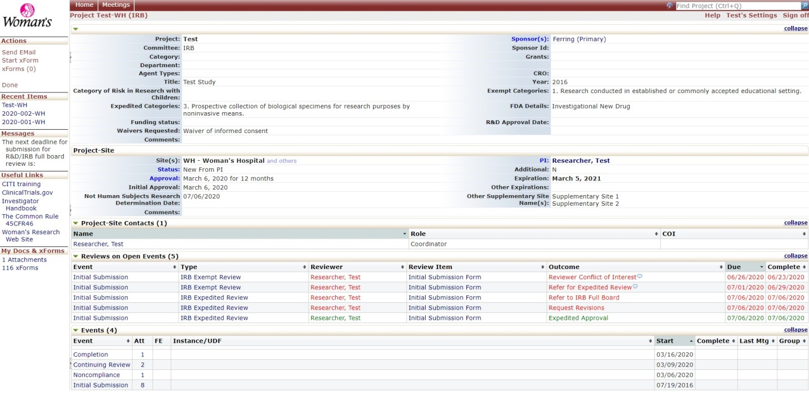
Click here to choose any event on the study
Return to top

After you choose the event, you will see the specific event information, and can also access any attachments associated with the event:
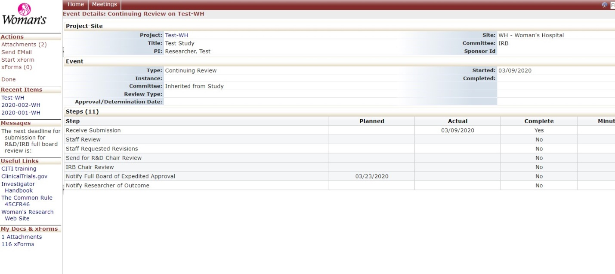
You can always click “HOME” on the top menu bar to return to your dashboard.
If you have any questions about using IRB Manager, please contact Ericka Seidemann at 225-231-5296 or send an email to Ericka.seidemann@womans.org or research@womans.org.
Return to top

