HOW TO REGISTER FOR CITI TRAINING
Go to citiprogram.org and click on “register” at the top right corner of the screen
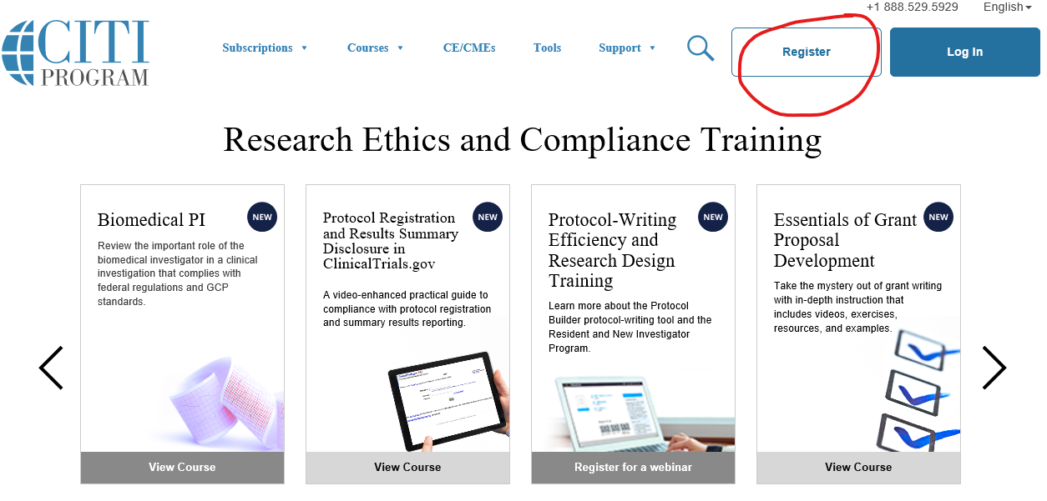

Enter Womans (no apostrophe) as your institution, and click the box next to “I Agree” to the Terms of Service.
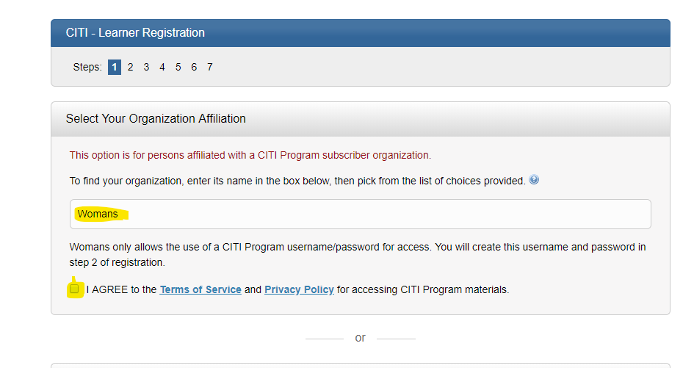

Another check box will appear under the Terms of Service. Click on that box and continue to create your CITI username/password

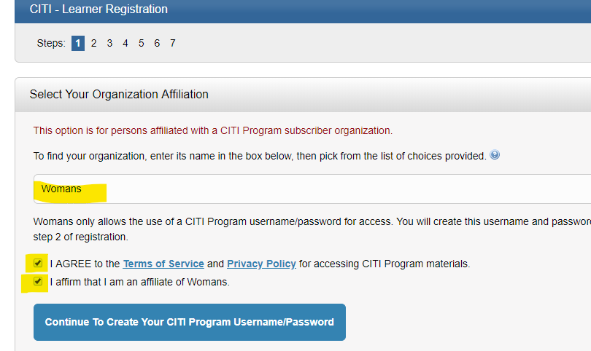

Step 2, enter your name and email address
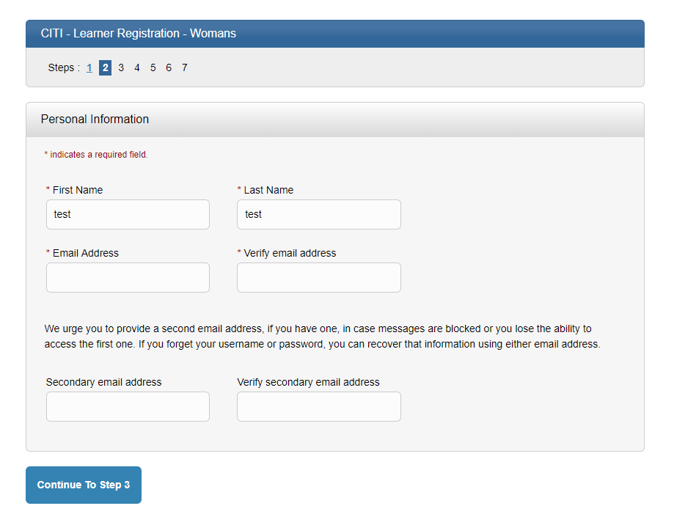

Continue to Step 3 and create your username and password
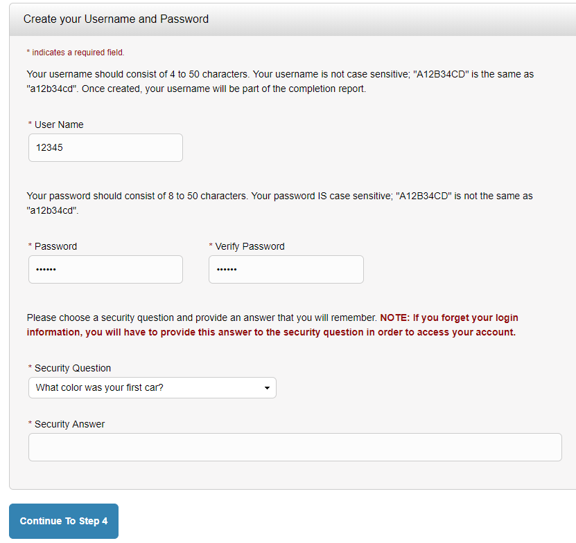

Step 4, choose your country of residence
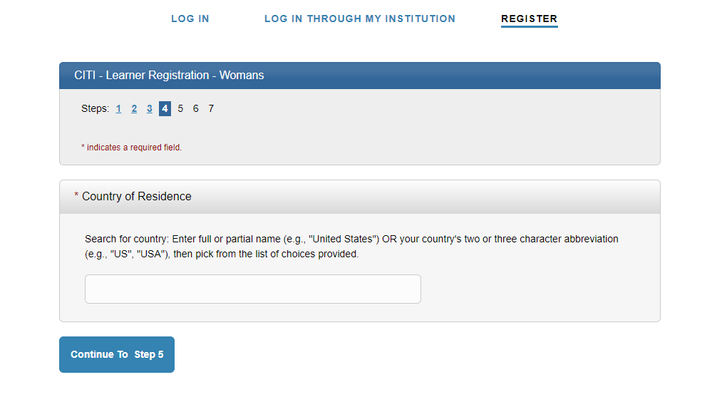

Step 5, indicate if you would like to receive continuing education credit
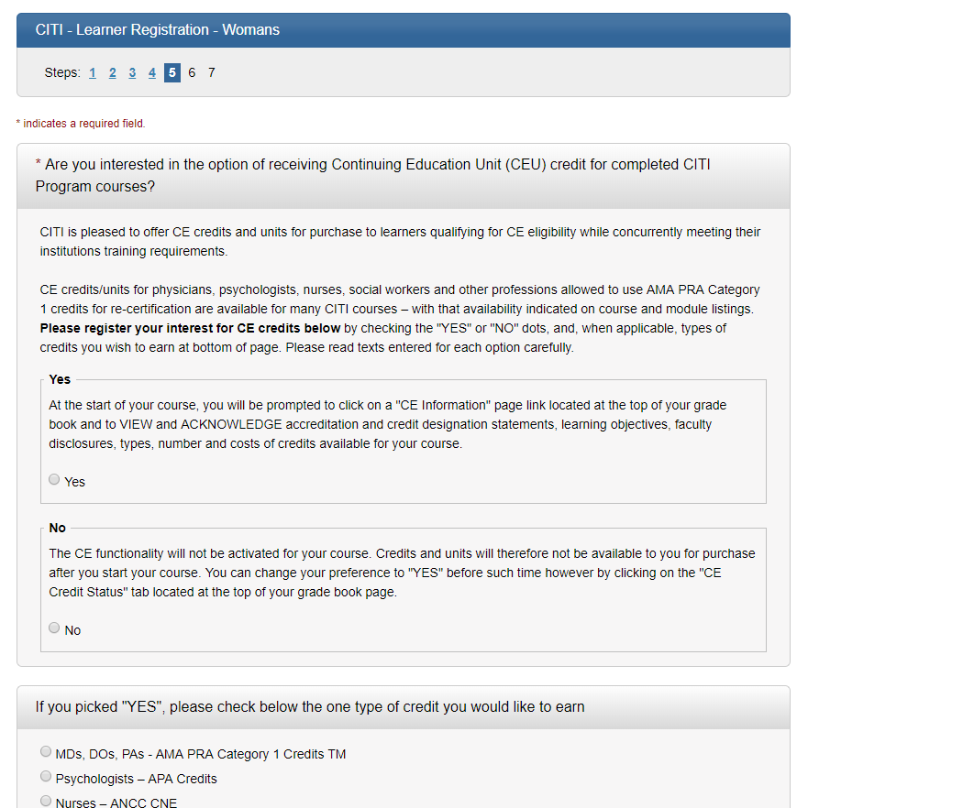

Step 6, provide institution information.
Please note: if you do not have an Employee ID Number, you may use your birthdate. Enter your birthdate as MMDDYYYY (January 2, 1970, would be 01021970).
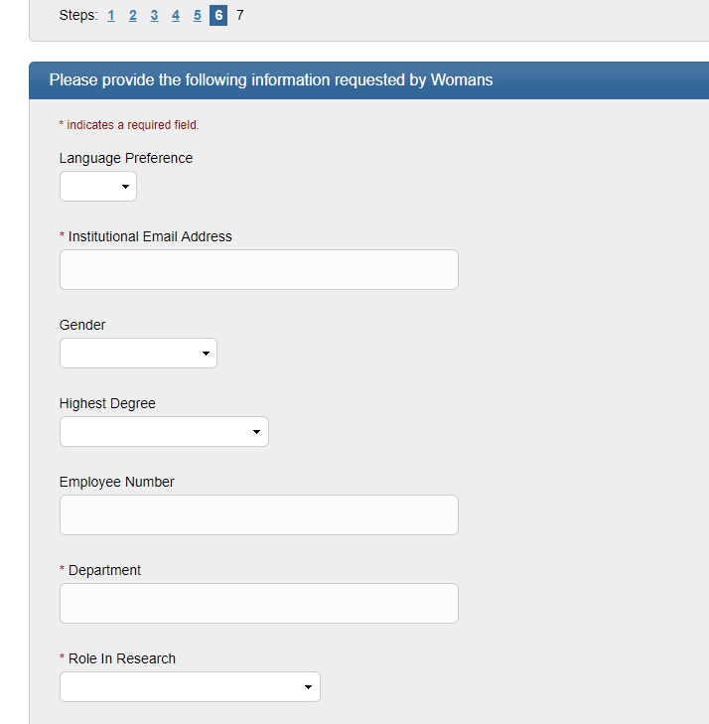

Step 7, select your curriculum. Choose Investigator, Study Coordinator, IRB Member/Staff, R&D Committee, or Institutional Official.
If you have multiple roles, you will need to complete the required modules for each role, such as being both an investigator and a member of the R&D Committee. You may need to update your profile first before proceeding.
The Main Menu lists the courses you have chosen. The Main Menu also provides a number of Learner Tools designed to help you. The Add a Course or Update Learner Groups link allows you to go to the enrollment questions and change your "Learner Group" by providing new responses to the enrollment questions. TO ADD R&D COURSES, CHOOSE QUESTION #3.
To Update Your Learner Group to add R&D Courses:
1).You may need to update your profile information before the system will allow you to update your courses. If the profile page pops up, update your information and click “update” at the bottom of the screen.
2). Choose “View Courses” by Woman’s
3). Choose Active Courses – Learner Tools
4). Click “Add a Course” at the bottom of the screen
5). Scroll to Question 3: R&D Committee and choose the R&D Course
6). Click “submit”

Final step, choose Finalize Registration.
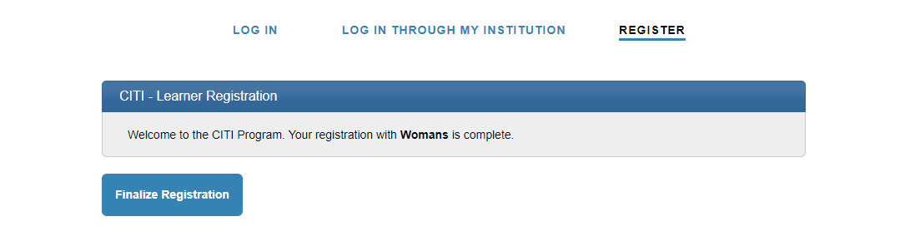

Choose “View Courses” next to Woman’s
If no courses are listed, you may need to scroll down to “Learner Courses for Woman’s” and choose “add a course.” Answer Question 1 to add courses applicable to your role in human subjects research, answer Question 2 to add courses for Good Clinical Practice (for investigators, IRB members, and study coordinators only), and answer Question 3 to add courses if you are a member of the Research and Development Committee.

